MacGuffin Hardware

The files listed below are contained in
MacGuffin Hardware files.zip

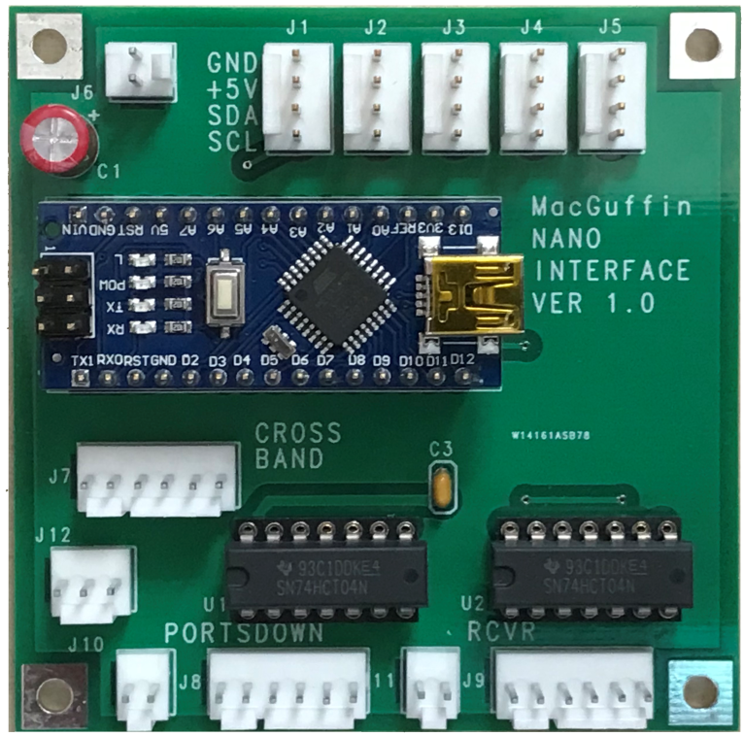
Nano Panel
MacGuffin Nano Panel V1-01 SCH.pdf
MacGuffin Nano Panel V1-01 BOM.xlsx
<link to shop for PCB>

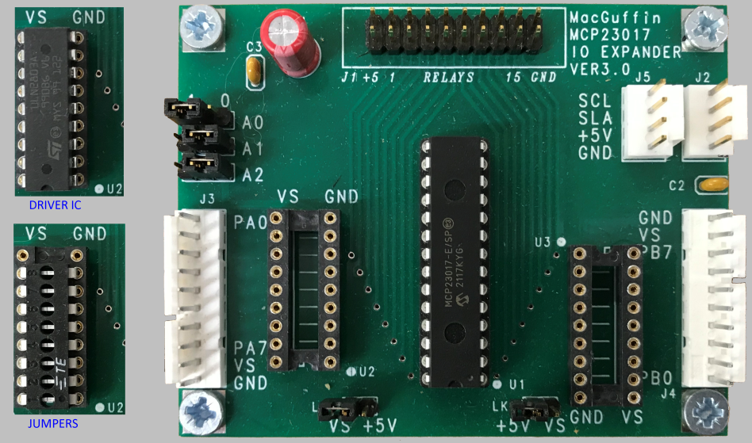
IO Expander
MacGuffin IO expander V30 SCH.pdf
MacGuffin IO expander V30 BOM.xlsx
<link to shop for PCB>

List of RF Relays These relays were available while the MacGuffin was being developed. Some technical details are included.
MacGuffin Relay List.xlsx

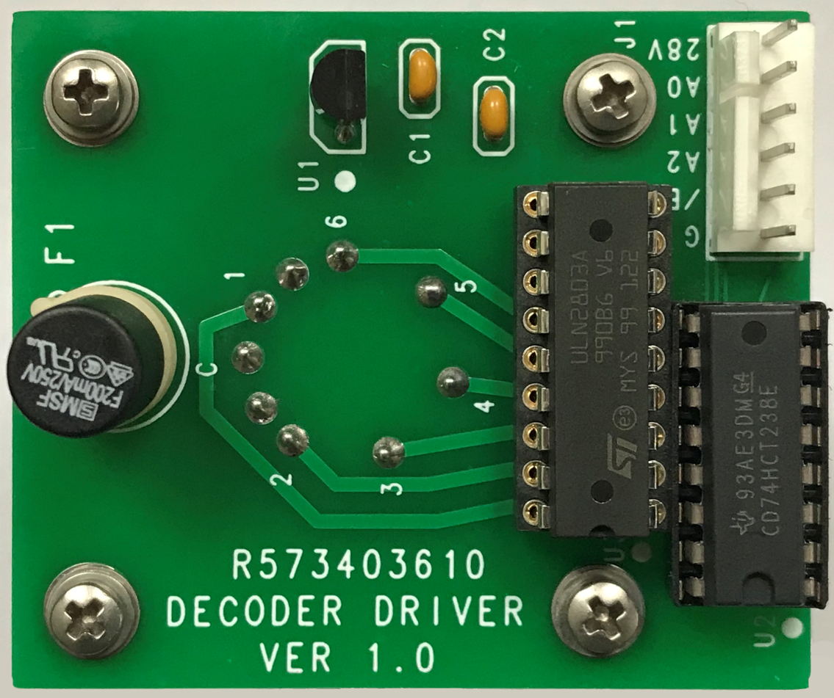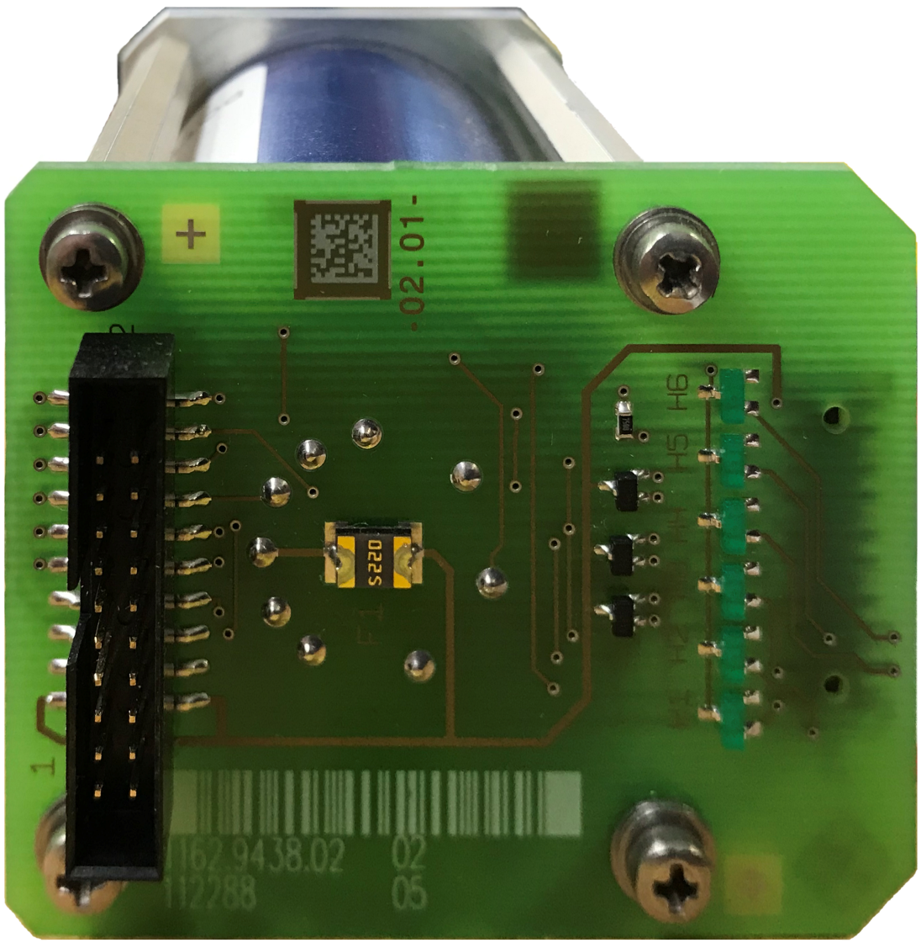

Decoder-Driver for 6 pole Relay R573403610 This board replaces the PCB on the relay to convert the interface of the relay from separate wires for each coil to 3 bit logic level control.
R573403610 DECODER DRIVER V1-01 SCH.pdf
R573403610 DECODER DRIVER V1-0 BOM.xlsx
<GERBER files> This PCB is not supplied by the BATC

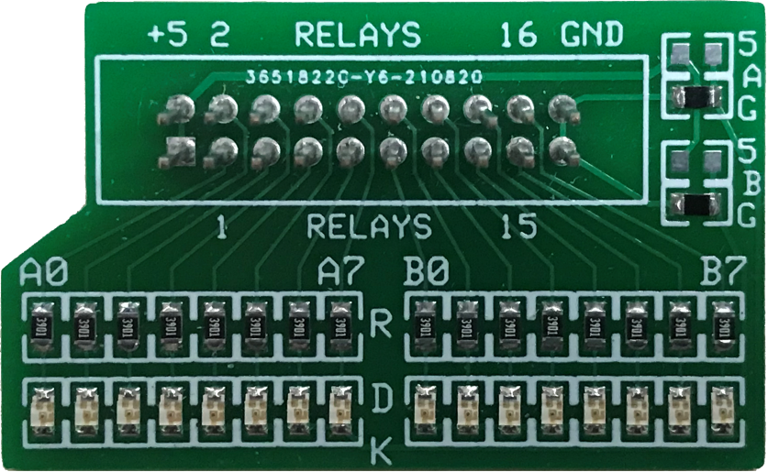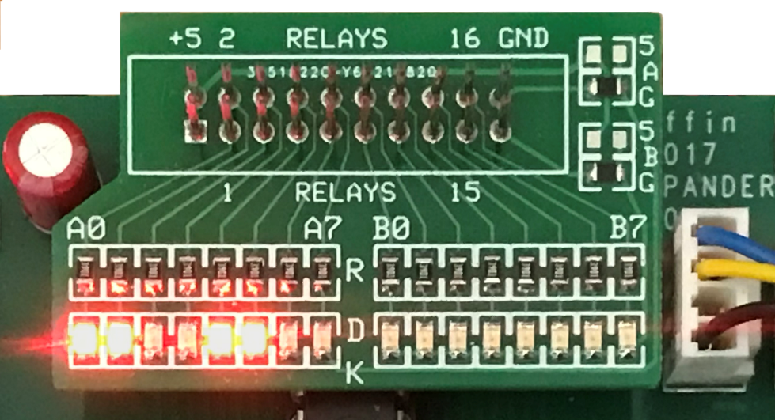
Test LEDs This board is useful for checking that the IO expander outputs are operating as intended. It can be used with or without the relays connected. Operating without relays allows testing without risk of damage to the RF equipment.
MacGuffin IO Expander test LEDs SCH.xlsx
MacGuffin IO Expander test LEDs BOM.xlsx
<GERBER files> This PCB is not supplied by the BATC

Reference Project Example drawing and a list of suggested parts
MacGuffin Interconnection V1-0.pdf
MacGuffin Interconnection BOM V1-01.xlsx

IO Worksheets These two files are for planning connections to the IO expanders.
MacGuffin IO Expander worksheet.xlsx Spreadsheet for recording connections to an IO expander
MacGuffin IO expander drawing.pdf Same as above but for paper and pencil

Drawings for Switch Labels
MacGuffin Sw Dec Dial.pdf MacGuffin Sw Hex Dial.pdf
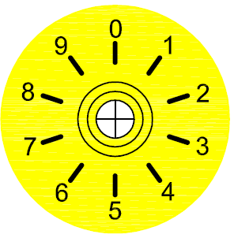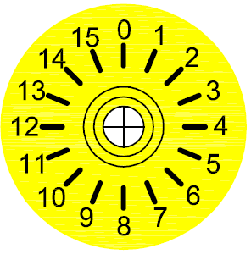

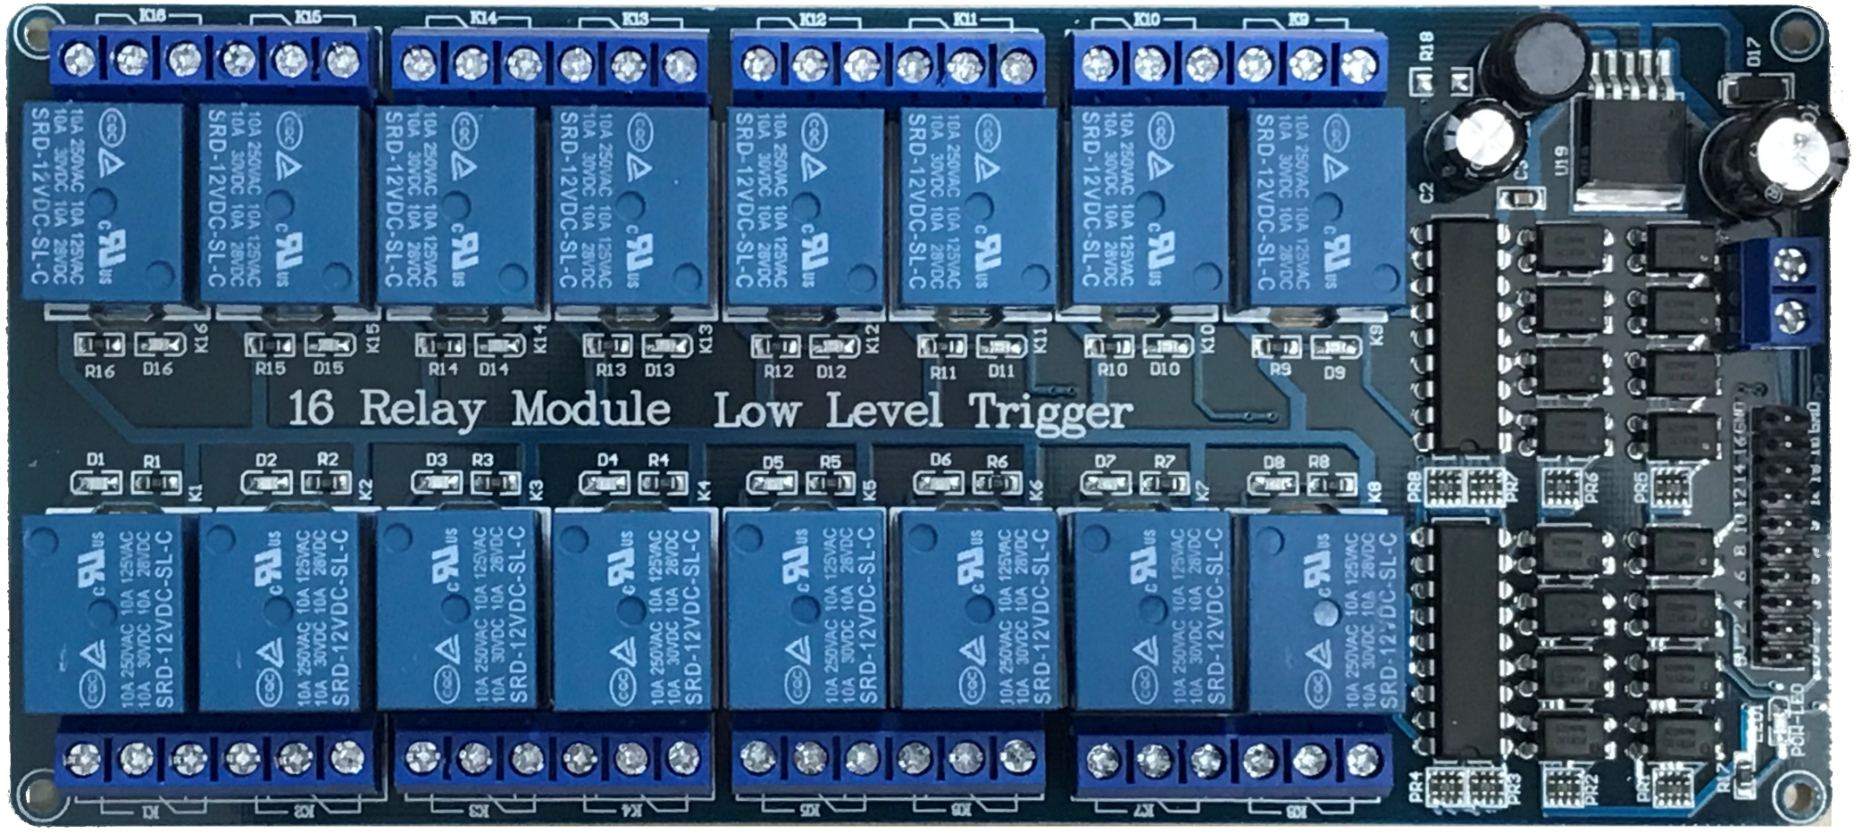

eBay 16 Channel relay board

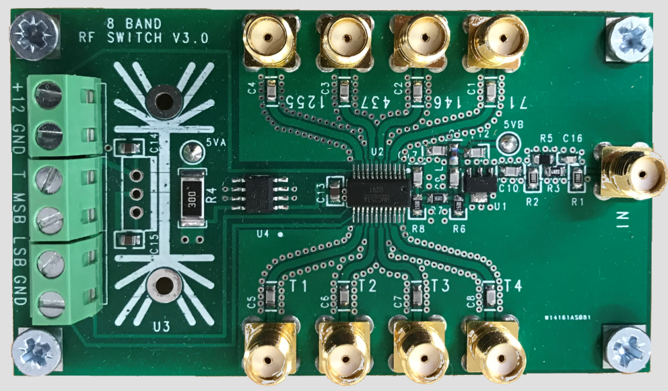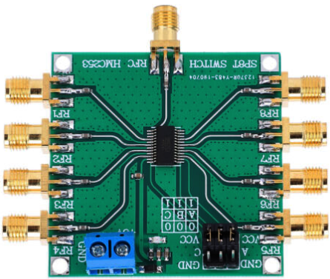

BATC 8 band RF switch eBay 8 band RF switch

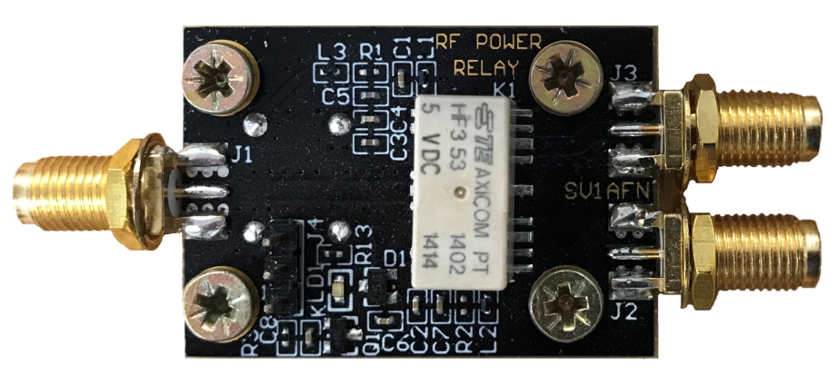

SV1AFN RF RELAY 3 GHZ 50 OHM SPDT for T/R switching

