Welcome to our Village

We represent several activities associated with the hobby of Amateur Radio.
AMSAT-UK | 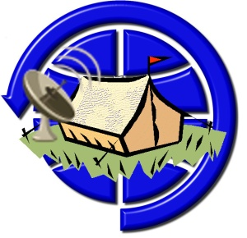 | AMSAT-UK represents the amateur satellite community in the UK whose members not only operate amateur satellites but also help to design, build and fund them.  AMSAT-UK is a wholly voluntary club. All its officers and members do any work on a purely voluntary basis. AMSAT-UK has no paid employees and is run solely to support its members in their pursuit of their hobby of amateur radio space activities.  https://amsat-uk.org/
British Amateur Television Club |  | Whether it’s watching live video from the International Space Station, developing high speed data links to carry digital TV signals, helping produce programs for live streaming, building pre-amps and high-power amplifiers for the microwave bands or restoring vintage cameras and outside broadcast vans, the world of Amateur Television (ATV) has something to interest everyone!  https://batc.org.uk/
UK Microwave Group |  | The Group aims to provide information, advice and, most of all, support to all radio amateurs working on projects from 1GHz upwards. It is not dedicated to any one mode or band and is certainly interested in promoting satellite, wideband, ATV and data as well as weak signal operation.  https://www.microwavers.org/
UK High Altitude Society |  | The UK High Altitude Society (or UKHAS) is an umbrella organisation linking different high-altitude projects together to provide a forum to share information. This involves balloons, airships, rockets and any other projects for exploring the edge of space.  https://ukhas.org.uk/

During EMF will be doing presentations, practical demonstrations and hands on experiences of our hobbies. See the signage and visit our village page: https://wiki.batc.org.uk/EMFcamp_2024.
As you can imagine, a lot of effort goes into setting up a village like this and we are grateful to AMSAT-UK, BATC, UKuG
The Radio Communication Foundation |  | https://commsfoundation.org/
Badgersoft.com Limited |  | www.badgersoft.com
Paul Marsh | 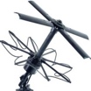 | uhf-satcom.com/
who have all provided financial sponsorship of the marquee and outreach materials.

