**Notes for converting MacGuffin Word files to Wiki**

W MacGuffin Main Page.docx

W MacGuffin Hardware.docx

W MacGuffin IO Definition.docx

These files are images of what the Wiki pages are intended to look like.

Word inserted page breaks making big spaces in unintended places.

There are several places where blue text indicates where links to zip files or other Wiki pages should be added.

While photos have been inserted the originals are in a folder in case they need to been redone. The images below are to help identify the source filename.

**Main page photos**

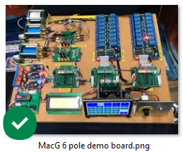 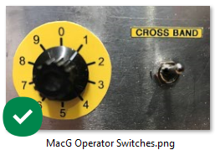

**IO definition page photo**

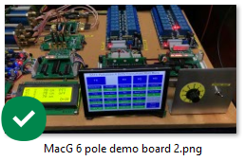

**Hardware page photos**

